Question 16:
Create a dictionary of five sports and the number of players required. Modify one value.
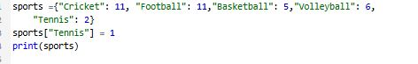
Output:

